# RAID REASSESSMENT

Purpose

To get an overall architecture in what each overall node will be used for. After assessing any hardware constraints, we may encounter based on recommendations set forth by the OpenStack book 1.1. We formed a general idea that RAID 5 would initially be the desired level to partition the data and provide fault tolerance with low overhead on the drives.

# Power Edge Specs

[Power Edge R710](https://www.itcreations.com/dell/dell-poweredge-r710-server?srsltid=AfmBOopiuocmKpkZ2reUJbVo480PnP2ThB9QjnACoX9cHaCPtlcaV0OC) x 2:

* CPU: 2
* Cores: 16
* Disks: 4 x 2.65GB
  + 4 x RAID5
  + description: RAID bus controller, product: MegaRAID SAS 1078
  + description: SCSI Disk, size: 836GiB (898GB)

[Power Edge R730](https://savemyserver.com/dell-r730-tech-specs/?srsltid=AfmBOoq8wDtU_b4yGmLakQAp__Z7qTNVaCr7XTUl8EMeCvr2kWod4BQb):

* CPU: 2
* Cores: 40
* Disks: 8 x 3.6TB
  + 1 x RAID0, 7 x RAID5

**Total**

* CPU: 6
* Cores: 72
* Disks: 8 x 2.65GB, 8 x 3.6TB
* Network: 12 ports

|  |  |  |  |  |
| --- | --- | --- | --- | --- |
| **Name** | **Virtual cores** | **Memory** | **Disk** | **Ephemeral** |
| m1.tiny | 1 | 512 MB | 1 GB | 0 GB |
| m1.small | 1 | 2 GB | 10 GB | 20 GB |
| m1.medium | 2 | 4 GB | 10 GB | 40 GB |
| m1.large | 4 | 8 GB | 10 GB | 80 GB |
| m1.xlarge | 8 | 16 GB | 10 GB | 160 GB |

<https://people.csail.mit.edu/jon/openstack-ops/openstack-ops-manual.pdf>

# Example Node Spec Recommendations (Table 1.1)

**Controller – 710A with RAID 5**

* CPU: 2
* Cores: 12
* Memory: 32GB
* Disk: 2 x 300GB
* Network: 2 x 10G ports

**Compute – 730 with RAID 5**

* CPU: 2
* Cores: 12
* Memory: 128GB
* Disk: 2 X 600GB
* Network: 4 x 10G ports

**Storage – 730 with RAID 5**

* CPU: 2
* Cores: 12
* Memory: 64GB
* Disk: 2 x 500GB, 24 x 600GB
* Raid Controller: PERC H710P Integrated RAID Controller, 1 GB NV Cache
* Network: 2 x 10G ports

**Network – 710B with RAID 5**

* CPU: 1
* Cores: 6
* Memory: 32GB
* Disk: 2 x 500GB
* Network: 5 x 10G ports

**Total**

* CPU: 7 → 8
* Cores: 42 → 72
* Memory: 256GB →?
* Disk: 14.4GB → 28.8TB
* Network: 13 x 10G ports →12 ports

# 3 Node Architecture Figures

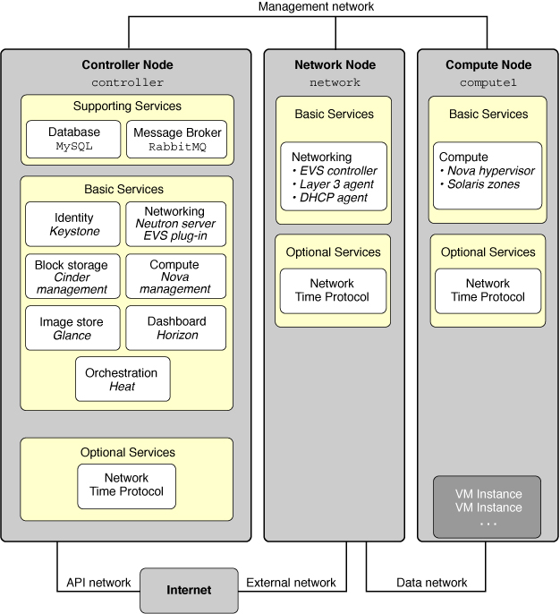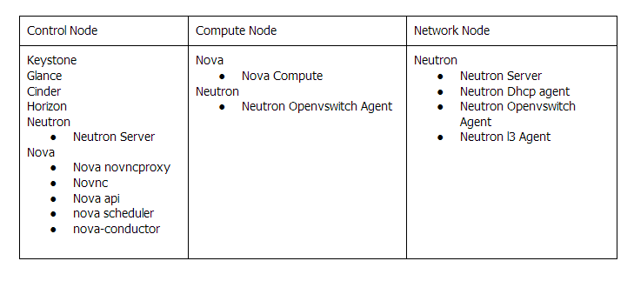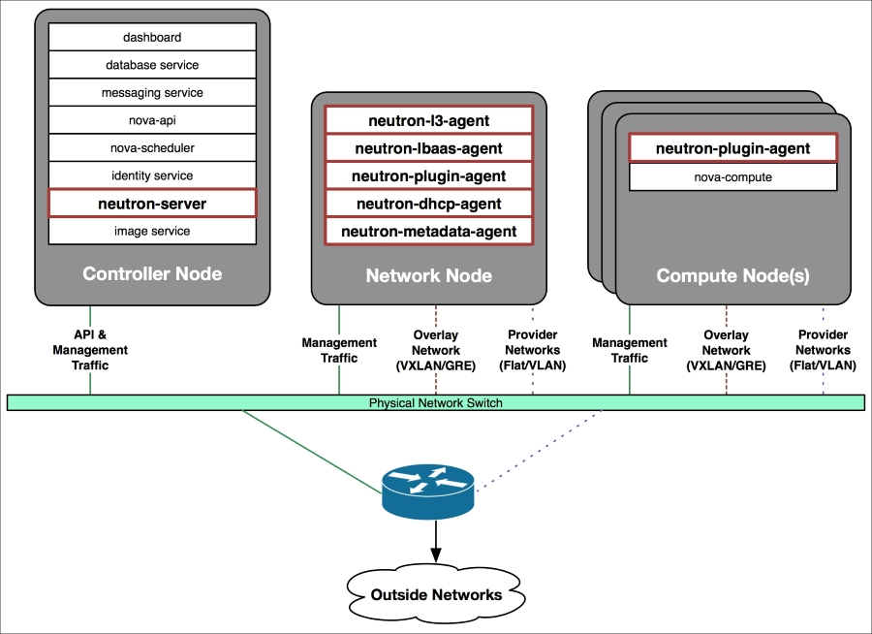

[Chapter 2. Recommended specifications | Red Hat Product Documentation](https://docs.redhat.com/en/documentation/red_hat_openstack_platform/10/html/recommendations_for_large_deployments/recommended-specifications#overcloud-compute-nodes)

[Three-Node Architecture Overview - Installing and Configuring OpenStack in Oracle® Solaris 11.2](https://docs.oracle.com/cd/E36784_01/html/E54155/archover.html)